 | Jorge Blanco Rey  Ángel Casanova Bienzobas  S.Xiao Fernández Marín | jorge.blancor@estudiante.uam.es  angel.casanova@estudiante.uam.es  sofiax.fernandez@estudiante.uam.es
TEST PLAN and test results
Application: Citicide



DATE: 10/05/2020
GROUP: 2291
PAIR: 2

1. TEST CASE: SEARCH GROUP

  - Use Case: Search Group
    - Primary actor: Registered User.
    - Stakeholders and goals:
- Registered User: To enter in the “Group” menu interface, where he can make all the actions related with a group, as individual or if he is a group owner, he can access to all the functions of the group, taking those actions in name of the whole Group.
- Administrator: He can check the behaviour of the groups to decide whether ban a user or not.
    - Preconditions: The user is identified by the login use case.
    - Success Guarantee (Postconditions): The user could display all the groups that he
belongs to, also he could search a new group to log in and access any possible action related with group management through this menu.
    - Main Success Scenario:
- The user selects the “Groups” tab.
- The user selects a group (if any) or searches for a new one.
- The user can join the group.
- The user displays the information of the group.
    - Extensions (Alternative paths):
- The user joins a new group.
- The system decides if the user can enter in the group or not.
- The system displays a new group in the current groups list.
- The user leaves a group.
- The system erases a group from the current group list.
- The user creates a new group.
- The user fulfils the information about the group.
- The system promotes the user from register user to group owner.
- The group is included in the database and it is ready to anyone that wants to join in.
- The user can see the affinity between two groups (only if he belongs to both groups).
- The system displays the affinity coefficient or an error.
    - Technology and Data Variations List:
- Option to search new groups.
- Option to display data about the groups that the user belongs to.
- Option to display the Affinity Report.
- Option to join/leave groups.
    - Frequency:
- Very high, in order of hundreds per current users.
    - Open Issues:
- In a future version the group may be expanded, so it is possible to append new extensions to this main menu.

From all the possible paths, we are going to test the main one.

1.2. Test case design (including expected inputs and outputs):

Preconditions:
The system already has the user “Jorge” accepted by the administrator, and the group “Videogames” and subgroup “Zelda” created by another user. Then the following steps are performed:
  - The system shows the login window.
  - The user types his username, “Jorge”, with the password “j” and clicks on the “Log in” button.
  - The user clicks on the combo box and appears a list with “Your groups”, “Voted projects”, “New groups”, “New projects” and “Your notifications”.
  - The user clicks on the “New groups” label, where all the existing groups and subgroups appear (Since, they are treated equally, because at the end a subgroup is also a group).
Scenario:
  - At the “New groups” page appears a list with all the groups that the system has.
  - To see the information of a group the user must click on one of them.
  - The user clicks on the “Zelda” group to see its information.
  - At the left-top corner the user pushes the “Join group” button.
  - It appears a pop-up displaying “You have joined the group correctly”.
  - The user clicks on the “Ok” button.
  - To check if the user has joined correctly to the group, he goes to the “Your groups” label of the combo box and sees that the “Zelda” group is there.

1.3. Test execution result

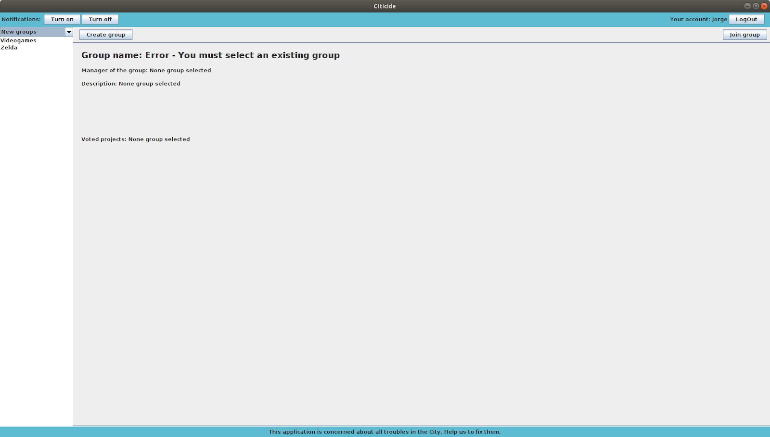

The user is in the “New groups” page, where he must select a group to see its information and join it. This window already has some groups created by other users as expected.

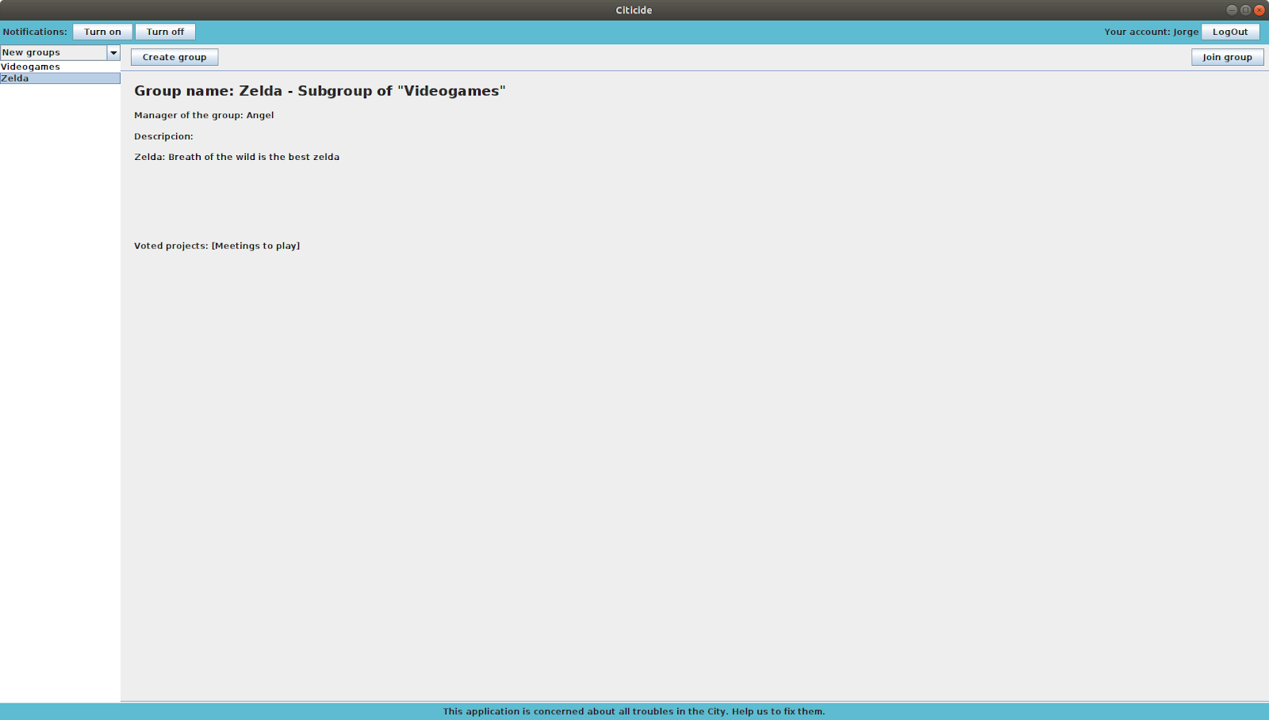
The user selects a group to see its information. As we expected, we can see the manager of the group, its description and voted projects.

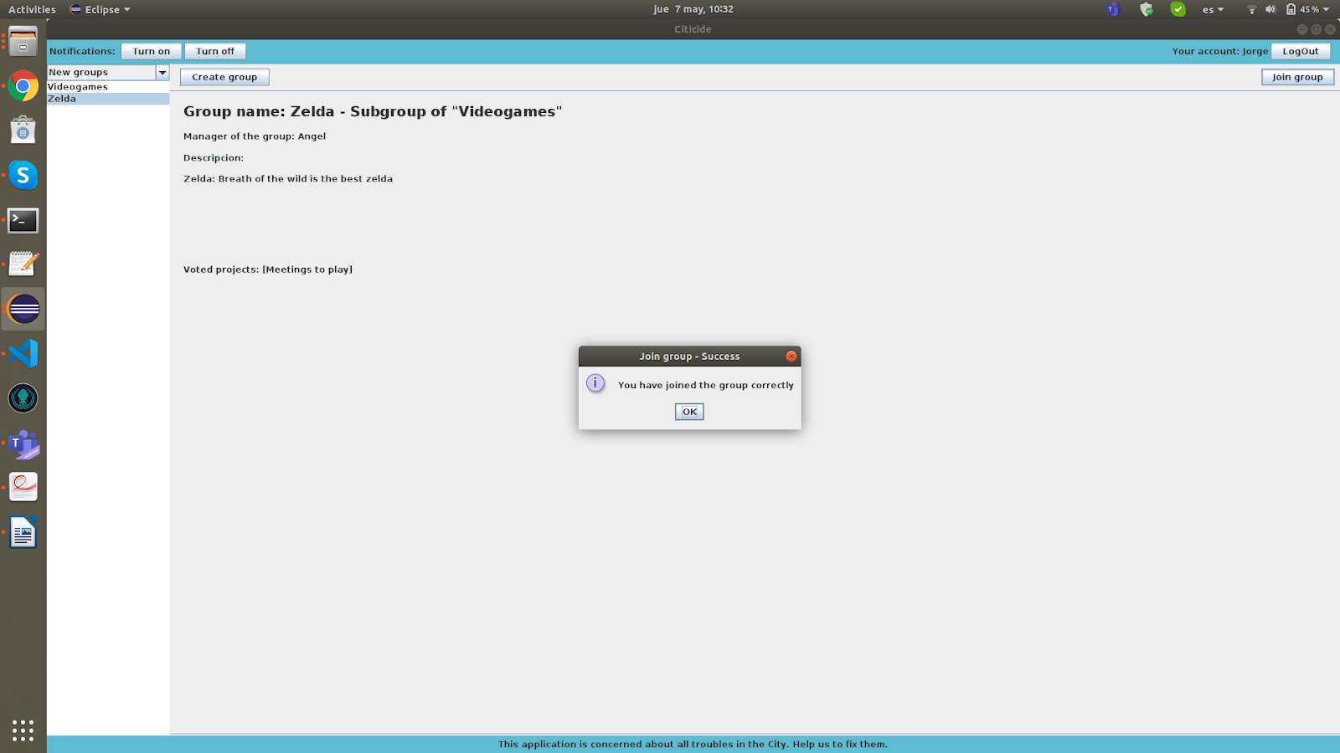
The user clicks on the “Join group” button for joining the selected group, in this case, “Zelda”. Since the current user is not a member of the group, as we expected, the system lets him join the group.

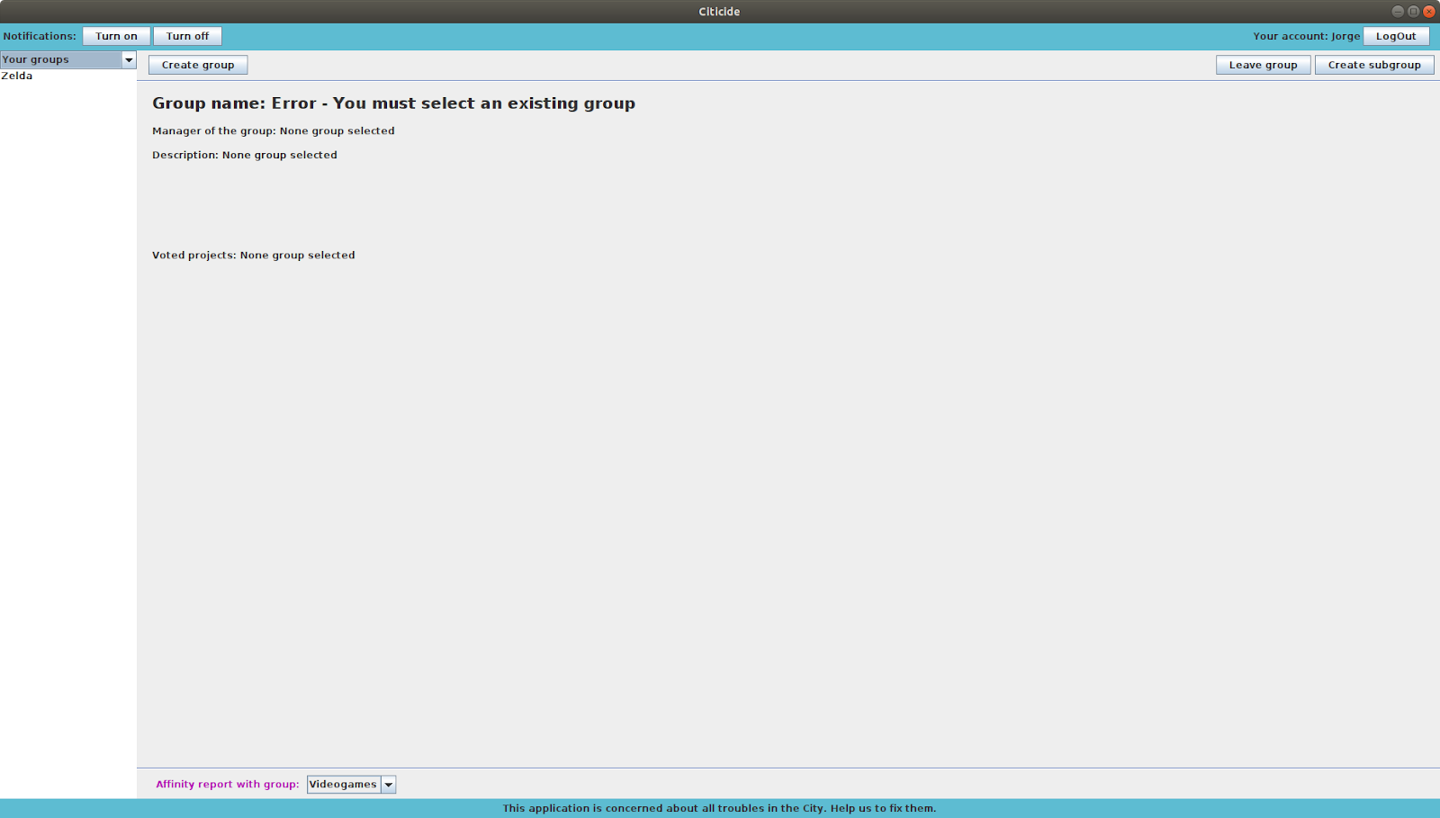
Then, if the user goes to “Your groups” page, he can see the group has joined, as we expected.

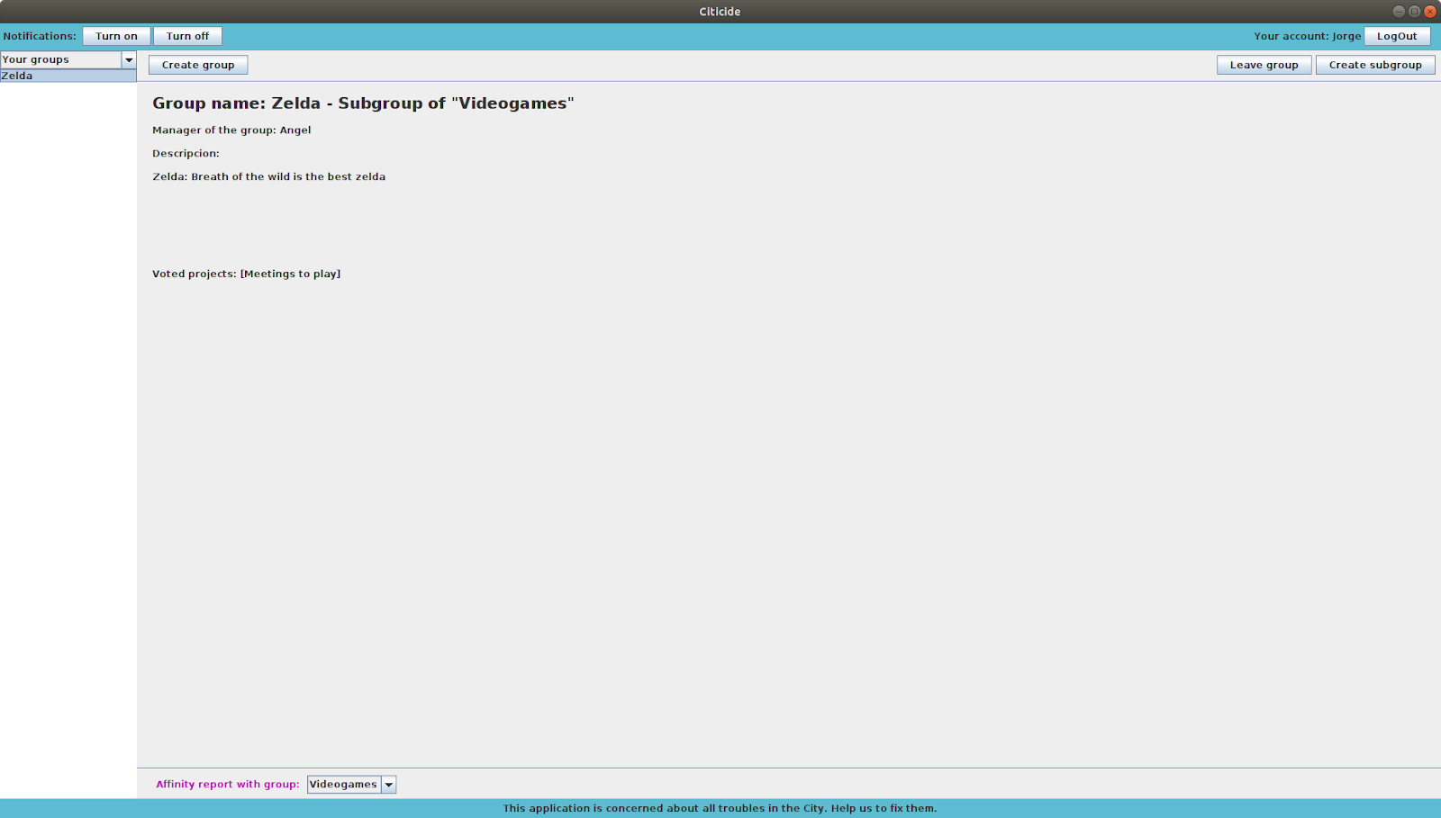
If the user selects the group he has joined, he can see its information. It happens the same as in the “New groups” page when clicking on a group (the information is displayed), as we expected.

Conclusion
To sum up, in this part we can see that everything works correctly, we can check it observing that the screenshots provided have the same results as the main scenario we described before.

2. TEST CASE: CREATE PROJECT AS A MANAGER

  - Use Case: Search Group

    - Primary actor: Registered User.
    - Stakeholders and goals:
- Register User: He must be a project owner, if not, an error pop-up will show a warning to the user. If he is a group owner, he will enter in the “Project” menu interface, where he can make all the actions related with a project, as a collective leader and also he can send the project to an external organization, then he can check the status of the project by an ID given by this organization, as a normal user.
- Administrator: Must accept or reject a new project, when it is created, he must also decide the minimum number of votes that the project needs in order to be sent to the organization.
    - Preconditions: The user is identified by the login use case, and he must be the owner of at least one group.
    - Success Guarantee (Postconditions): The user creates a project, in the name of a group that he owns, so the project will have the name of the group and will start with a number of votes equal to the number of users that the group has.
    - Main Success Scenario:
  - The group owner presses the create project button.
  - The group owner selects the “as group owner” option.
  - The group owner fulfils the information about the project.
  - The group owner waits for the administrator to accept the project.
    - Extensions (Alternative paths):
- In this case, they are not any extension to the use case.
    - Technology and Data Variations List:
- Option to create a project as collective.
    - Frequency:
- Very low, in order of one quarter per current user.
    - Open Issues:
- We do not think about future improvements in this use case.

From all the possible paths, we are going to test the main one.

2.2. Test case design (including expected inputs and outputs):

Preconditions:
We already have the “Bridge” and “Quarantine” projects created by other users. We also have the group “Meetings to play” created by the “Zelda” group. As the user we have chosen (Angel) is manager of the groups “Videogames” and “Zelda”, he can create a project as a manager. Then the following steps are performed:

- The system shows the login window.
- The user types his username, “Angel”, with the password “a” and clicks on the “Log in” button.
- The user goes to the “Voted projects” page (creating a project could also be done from the “New projects” page.

Scenario:
- The user clicks on the new project button.
- The user specifies a group he is manager of to create the project.
- The user fulfils all the fields (title, description...).
- The user creates the project.
- The system sends it to the administrator.
- The system sends a notification to the manager with the ID of the project.
- The administrator admits (and gives it a minimum number of votes) or rejects the project.
- If the project is admitted, the system sends a notification to all the group members (if they have them turned on), indicating that they have voted to the project by belonging to the specific group.
- Now the project is visible in the “New projects” menu to anyone and in the “Voted project” for all the group members.

2.3. Test execution result

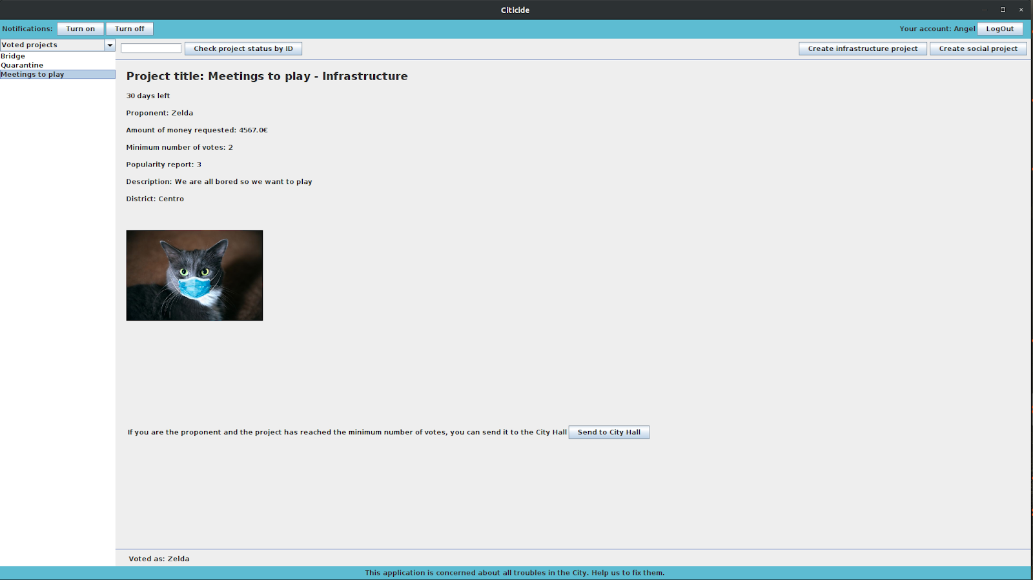
Once the user is in the “Voted projects” page, in the top-right side of the window, there are two buttons: “Create infrastructure project” and “Create social project”.

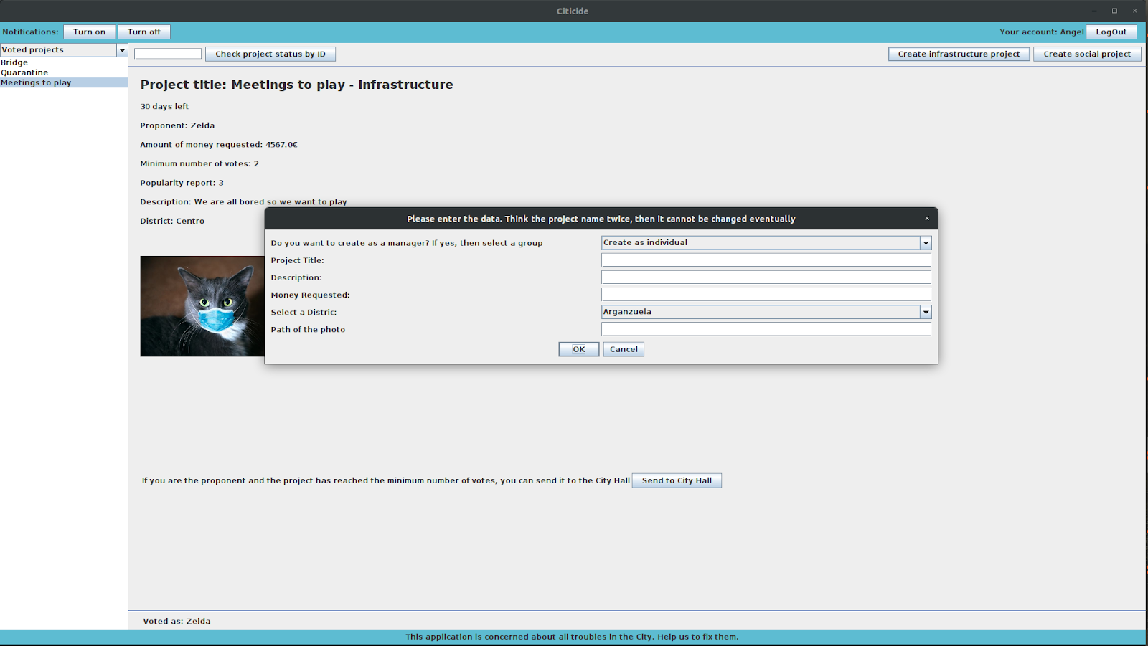
The user can choose any of them, when clicking on it, a pop up will appear and allow him to fulfil the fields to create the project. It is important that, in the first combo box, the user selects the group that he wants to create the project with, because otherwise he will create the project as an individual.

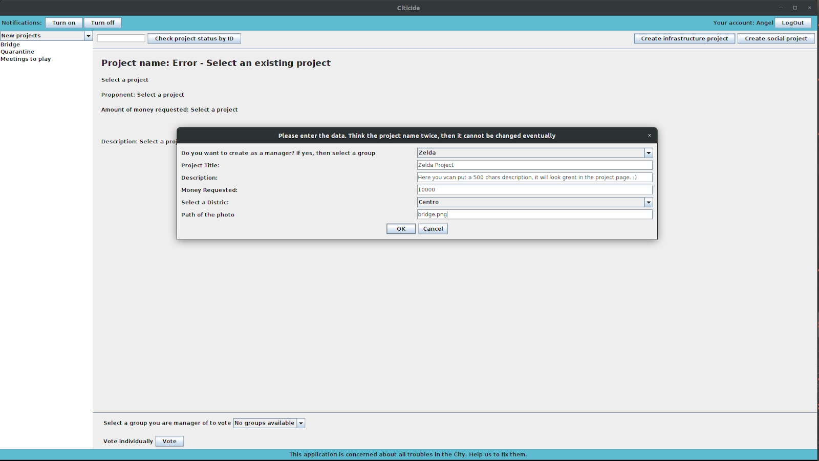
Once the user has fulfilled all the fields, he clicks “Ok” to create the project.

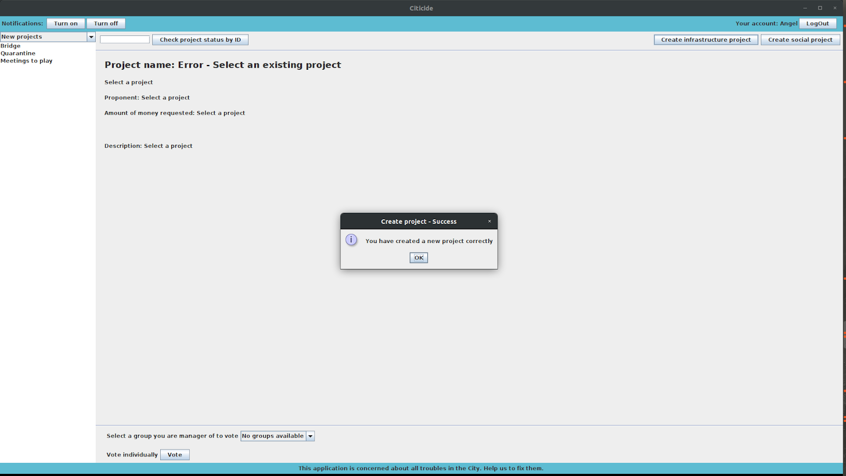
After clicking “Ok”, a pop-up will appear informing the project has been created correctly (since the input fields are correct, an error message will appear otherwise).

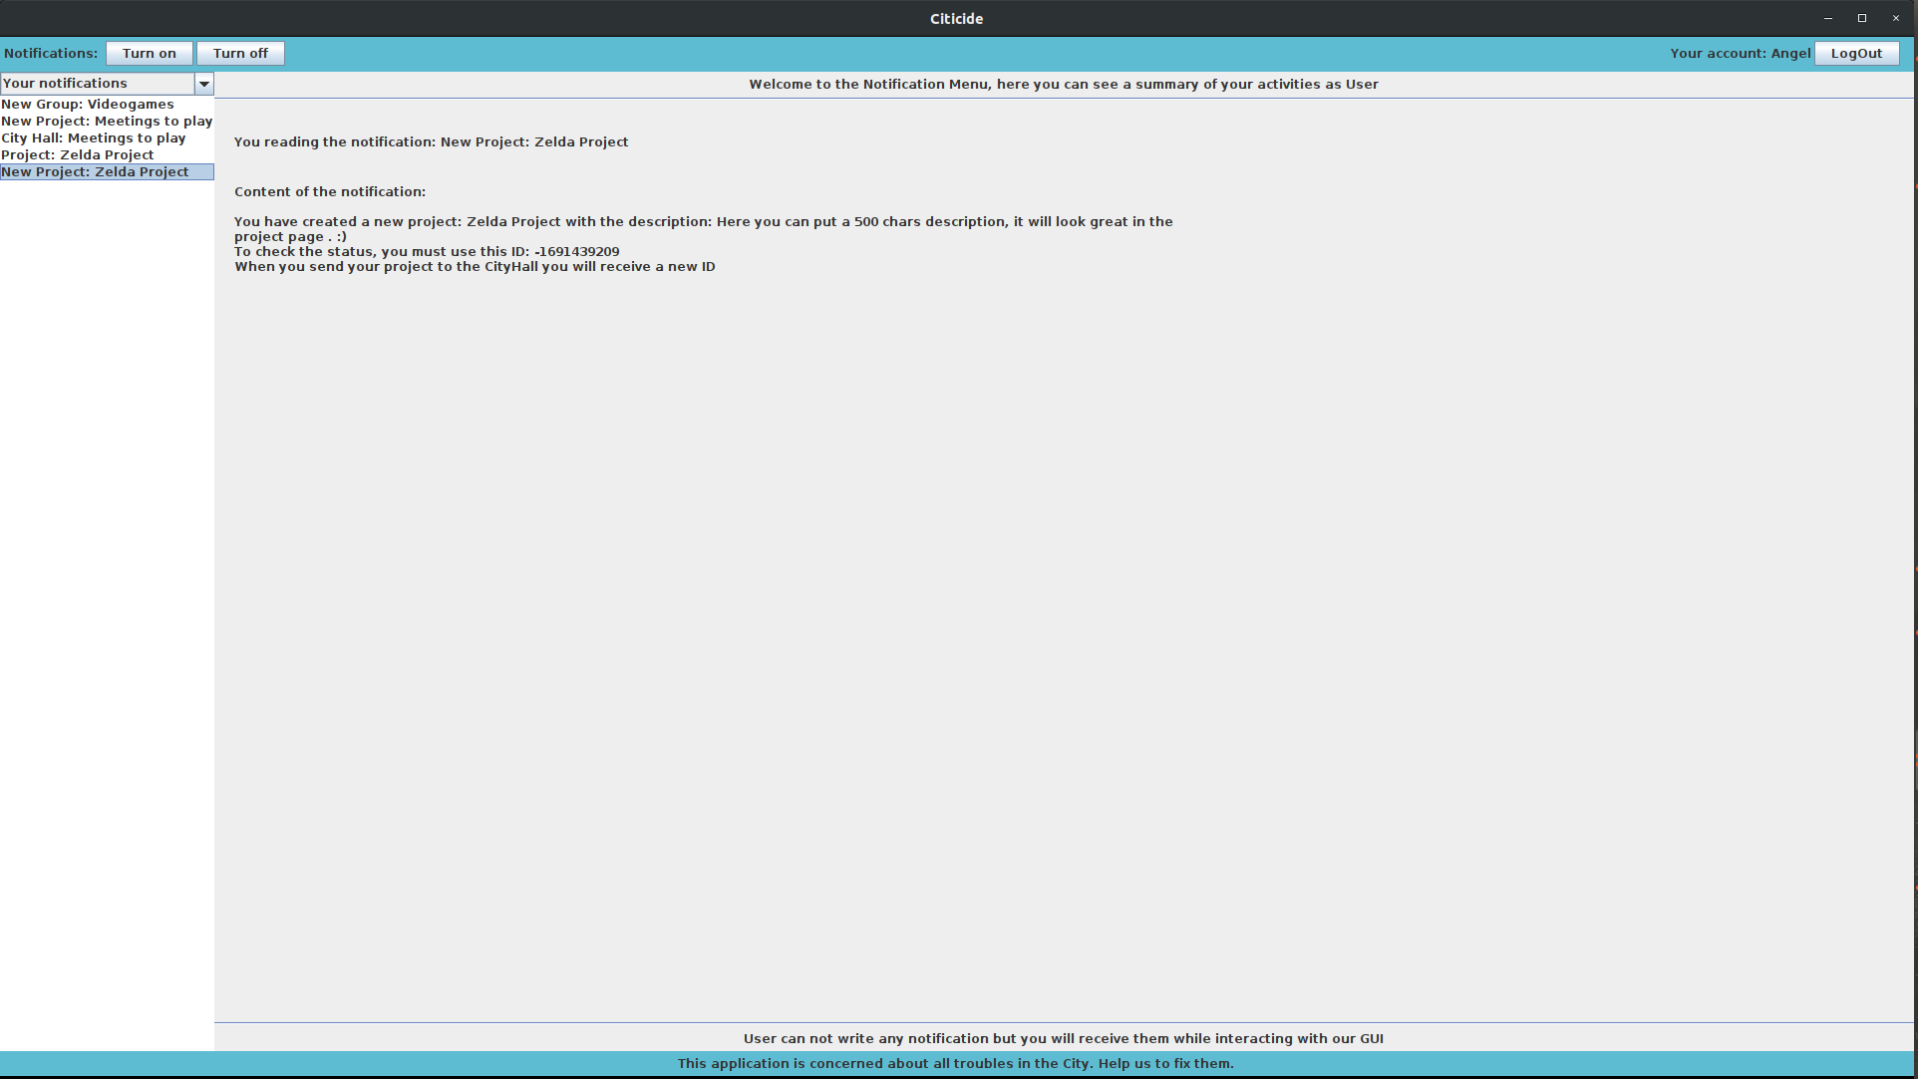
After the projects has been admitted, the user can go to “Your notifications” page and see the ID that he can use to track the status of the project (this notification is only sent to the manager).

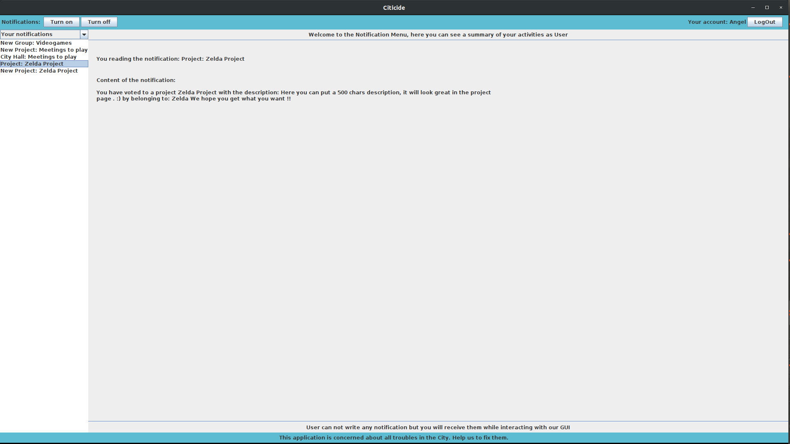
We can see that also a notification telling the user that he has voted the project is sent. This notification is only sent to the users who have them turned on. We must remark that this notification should only be sent when the project is accepted by the administrator and not at the moment it is created.

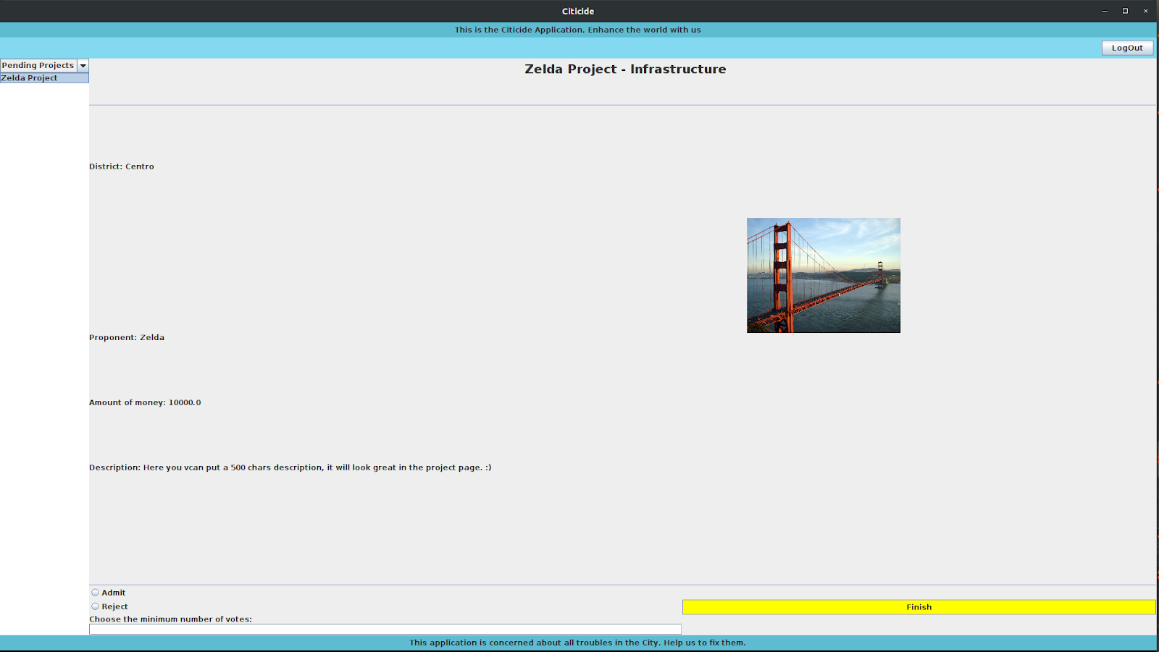
Then the administrator (user: Juan, password: “uameps”) must admit the project and give it a minimum number of votes.

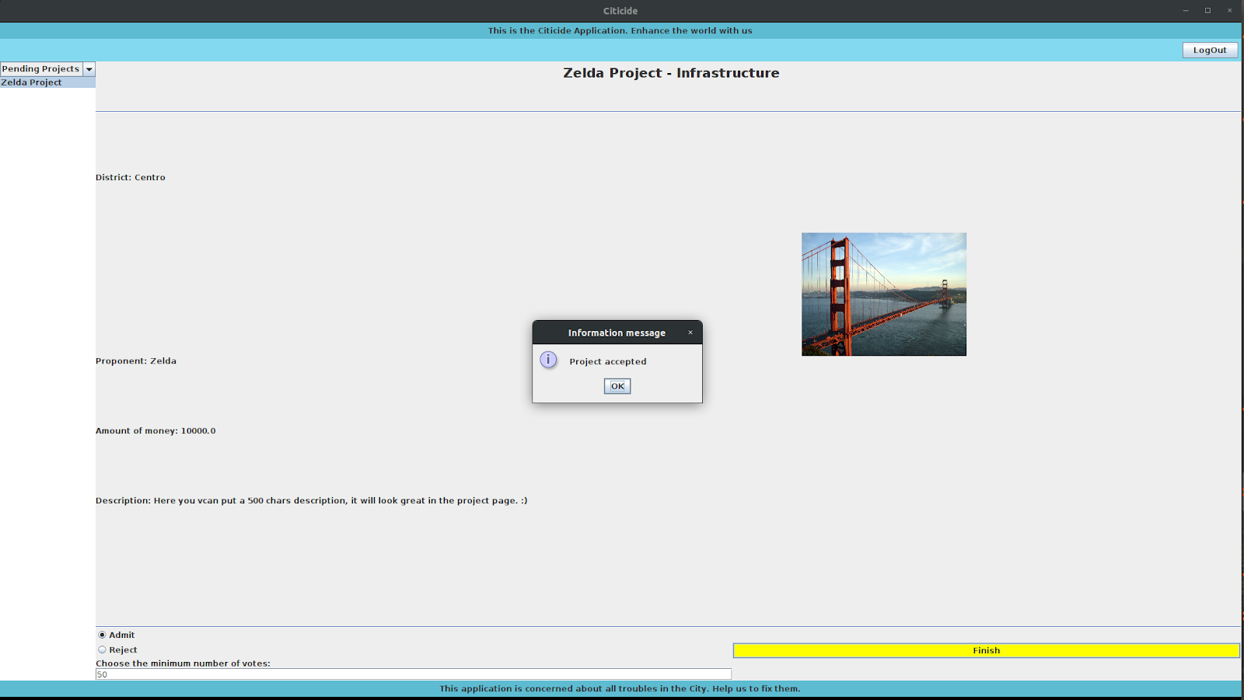
When the administrator clicks on the “Finish” button, a pop up will confirm that the operation has been performed correctly.

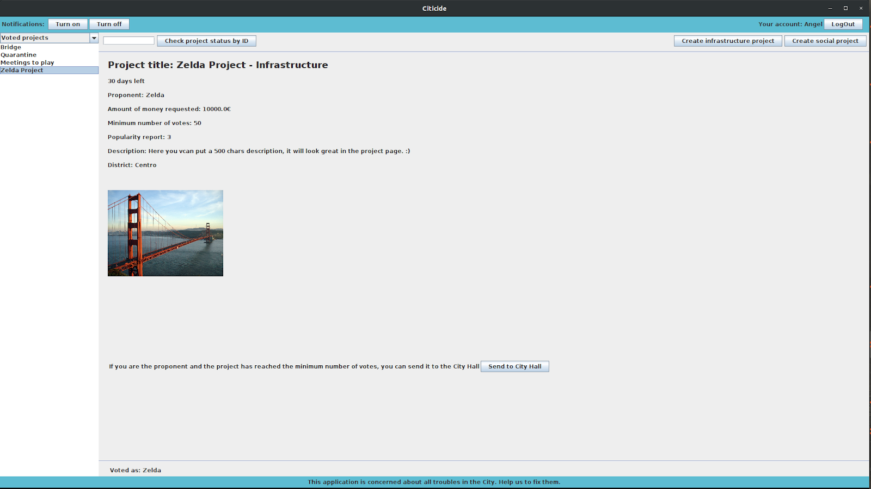
If the user goes to the “Voted projects” page, the new project that we have just created as a manager, appears with all its information.

Conclusion
To sum up the behaviour of the system while creating a new project as a manager of one group, we can observe through the screenshots that the program gives as the expected output, albeit we have fixed two visual bugs (see below) and that the notification of voted project appears instantly when creating it and not when it is really admitted.
We reckon that the rest procedures work fine due to the fact that the processes give a smooth response.

3. ANEX: BUGS FOUND WHEN TESTING
    - In “Controller.java”, between lines 172 and 173, we have added:
if(p.isAccepted() && !p.isExpired()) { // Only show accepted and no expired projects
Because otherwise, a visual bug appeared in the “Voted projects” page, the user could see the projects before they had been accepted by the administrator (this bug only happened if the project was created as manager of a group).

    - In “ProjectPage.java”, line 699 we send a notification with title “New project” + title we have to change it to “Project” + title, in order to make a distinction between others with the same name.
Also in the line 705, we send the notification to an array of users called “to”, but that is incorrect, we should put “toM”, which is a different array of users, so the notifications were not send properly.

